Fine-Tuning of Whisper for Hindi Dysarthric Speech Recognition
Capstone Project Proposal
Submitted by:
(102303691) Edwin Raphael
(102303962) Kanishka Bhardwaj
(102303679) Akhil Mittal
(102353021) Jivitesh Pasrija
(102303487) Arpita Tejpal

BE Third Year- COE
CPG No. 70

Under the Mentorship of:
Dr. Karun Verma (Associate Professor)
And Dr. Kashish Goyal (Assistant Professor)


Computer Science and Engineering Department
Thapar Institute of Engineering and Technology, Patiala
MARCH 2026
TABLE OF CONTENTS

- Mentor Consent Form 3
- Project Overview 4
- Problem Statement 5
- Need Analysis 6
- Literature Survey 7
- Objectives 8
- Methodology 11
- Project Outcomes & Individual Roles 14
- Work Plan 15
- Course Subjects 17
- References 18

Mentor Consent Form
I hereby agree to be the mentor of the following Capstone Project Team
Project Title: Fine-Tuning of Whisper for Hindi Dysarthric Speech Recognition
Roll No | Name | Signatures
102303691 | Edwin Raphael
102303962 | Kanishka Bhardwaj
102303679 | Akhil Mittal
102353021 | Jivitesh Pasrija
102303487 | Arpita Tejpal

NAME of Mentor: Dr. Karun Verma (Associate Professor)

SIGNATURE of Mentor: . . . . . . . . . . . . . . . . . . . . . . . . . . . . . . . . . . . .

NAME of Co-Mentor: Dr. Kashish Goyal

SIGNATURE of Co-Mentor: . . . . . . . . . . . . . . . . . . . . . . . . . . . . . . . . . . . .

Project Overview
Dysarthria significantly impairs speech intelligibility for Hindi speakers affected by neurological conditions such as stroke or Parkinson’s disease, especially in low-resource settings where standard ASR systems perform poorly. While Whisper achieves strong performance on normal Hindi speech (under 10% WER), it exhibits high error rates (50–70%+) on dysarthric inputs due to slurred articulation, breathiness, variability in severity, and lack of personalization. This project aims to develop a lightweight, browser-based assistive speech recognition system by fine-tuning Whisper-small on the Hindi Dysarthric Speech Dataset (HDSD) from IIT Roorkee using data-efficient techniques such as AdaLoRA, curriculum learning, and text-to-dysarthric synthesis augmentation to achieve under 15% WER with minimal (1–2 hours) per-speaker data.
The proposed methodology integrates three key components: (1) data-efficient adaptation of Whisper-small using parameter-efficient fine-tuning (AdaLoRA), model merging, and synthetic data generation to address dataset limitations; (2) severity-aware processing that classifies inputs based on dysarthria severity (e.g., Frenchay scales) and uses WhisperX confidence thresholding (entropy < 0.7) to identify low-confidence segments, followed by language model rescoring using IndicBERT; and (3) a query-responsive web interface built using Gradio and faster-whisper for real-time CPU inference (<2 seconds latency). The interface includes microphone input via Web Audio API, confidence-based visualization, interactive correction options, and support for voice commands, along with per-speaker LoRA personalization using short voice samples.
The expected outcome is a production-ready system achieving 40–50% relative WER reduction over baseline models on HDSD benchmarks, with real-time performance (RTF < 1.0), high user satisfaction, and improved communication efficiency in real-world scenarios such as healthcare and daily interactions. The system emphasizes privacy through local processing, lightweight deployment (<100 MB), and easy browser-based access. Additionally, it is designed to scale across Indic languages, addressing accessibility challenges for individuals with speech impairments and contributing to the advancement of dysarthric speech recognition research.

Problem Statement
To develop a lightweight, personalized, and data-efficient assistive speech recognition system by fine-tuning a Whisper-based model for Hindi dysarthric speech using limited data and targeted augmentation, with severity-aware adaptation, confidence-based error correction, and a query-responsive communication interface.

Need Analysis
Dysarthria is a motor speech disorder caused by neurological impairments that disrupt articulation, prosody, and speech intelligibility. These characteristics introduce high variability compared to typical speech, making automatic speech recognition (ASR) significantly less effective for dysarthric speakers [1]. As speech interfaces become increasingly integral to daily technology use, this limitation creates a critical accessibility barrier.
Despite major advances in ASR, current systems remain poorly adapted to dysarthric speech. Models trained on large-scale healthy speech datasets exhibit substantially degraded performance when applied to pathological speech, with word error rates (WER) often exceeding 30% on benchmark datasets such as TORGO and UASpeech [1], [3], [4]. This performance gap is primarily driven by variability across speakers, severity levels, and mismatch between training and real-world conditions.
A key challenge is the scarcity of high-quality dysarthric speech data. Existing datasets are limited in size and predominantly English, restricting the development of robust and multilingual ASR systems [3], [4]. Recent research shows that data augmentation and transfer learning can mitigate these limitations, improving model robustness and reducing WER in low-resource settings [5].
The problem is more pronounced for Hindi, one of the most widely spoken languages, where dedicated dysarthric ASR systems are largely absent. The Hindi Dysarthric Speech Database (HDSD) developed by Manoj Tripathy at IIT Roorkee provides a crucial resource for addressing this gap [6]. However, its limited scale necessitates data-efficient modeling approaches.
Therefore, developing a Hindi-specific dysarthric ASR system leveraging HDSD, combined with augmentation and transfer learning, represents a timely and impactful research direction toward inclusive speech technologies.

Literature Survey
- Introduction
Dysarthria is a neurological speech disorder that affects articulation, speech timing, and clarity. Individuals with conditions such as Parkinson’s disease or stroke often produce slurred or irregular speech, making communication difficult. Automatic Speech Recognition (ASR) systems are typically trained on clear, healthy speech and therefore struggle to recognize dysarthric speech. This problem becomes more severe in low-resource languages like Hindi, where annotated dysarthric datasets are limited. As a result, there is a need for adaptive and data-efficient ASR systems that can handle such speech variations effectively.
- Current Speech Recognition Systems
Modern ASR systems rely on large pretrained models. One such model is OpenAI Whisper, which is trained on a massive multilingual dataset and performs well across many languages [7]. However, it assumes normal speech patterns and fails to generalize to dysarthric speech due to distorted pronunciation and irregular timing.
Self-supervised models such as wav2vec 2.0 improve speech representation learning using unlabeled data [8]. In addition, multilingual datasets like IndicVoices help improve recognition across different Indian languages [9]. Despite these advancements, these systems are not specifically designed for pathological speech.
- Dysarthric Speech Recognition
Dysarthric speech is characterized by imprecise articulation, irregular pauses, reduced pitch variation, and phoneme distortion. These factors make it difficult for ASR systems to accurately map speech to text.
Research in this area relies on datasets such as UASpeech [3] and TORGO [4], which contain speech samples from individuals with different severity levels of dysarthria. However, these datasets are primarily in English. The Hindi Dysarthric Speech Database (HDSD) [6] has been introduced to address this gap, but it is still limited in size.

A comprehensive survey by Qian and Xiao [1] highlights key challenges such as data scarcity, speaker variability, and differences in severity levels, emphasizing the need for more robust and adaptive systems.
- Fine-Tuning for Dysarthric Speech
Fine-tuning pretrained ASR models is an effective approach for adapting them to dysarthric speech. Instead of training from scratch, models are updated using smaller datasets, allowing them to learn distorted speech patterns. This approach improves performance in low-resource settings and reduces computational requirements [11].
- Data Augmentation Techniques
Data augmentation is commonly used to address limited data availability. Traditional methods such as noise addition, speed variation, and pitch shifting improve general robustness but do not fully represent dysarthric speech characteristics.
Recent approaches focus on generating synthetic dysarthric speech to increase dataset diversity. Soleymanpour et al. [5] demonstrate that such synthetic data can significantly improve model performance by helping the system learn distorted speech patterns more effectively.
- Integration with Language Models
Combining ASR systems with large language models (LLMs) improves recognition accuracy by providing contextual understanding. Aboeitta et al. [2] show that integrating ASR with LLMs helps correct errors and improves sentence-level coherence in dysarthric speech recognition.
- Personalization in ASR Systems
Dysarthric speech varies significantly across individuals, making personalization an important aspect of ASR systems. Speaker-specific fine-tuning and adaptive learning techniques allow models to better understand individual speech patterns, leading to improved accuracy, especially in severe cases [12].

- Assistive Speech Recognition Systems
Assistive ASR systems are designed to help individuals with speech impairments communicate effectively. These systems require real-time processing, high accuracy, and low computational cost. Lightweight models such as Deep Speech enable deployment on mobile and edge devices, making them suitable for real-world assistive applications [12].
- Challenges and Research Gaps
Despite progress, several challenges remain. There is a lack of large-scale Hindi dysarthric datasets, high variability in speech patterns across individuals, and reduced performance in severe cases. Additionally, large model sizes make deployment difficult, and real-world evaluation of assistive systems is still limited. Most research focuses on English datasets and does not fully address personalization or assistive integration.
- Conclusion
Although modern ASR systems provide a strong foundation, they are not directly suitable for dysarthric speech recognition. Techniques such as fine-tuning, data augmentation, personalization, and integration with language models are essential to improve performance. For low-resource languages like Hindi, developing lightweight and adaptive ASR systems is crucial for enabling effective assistive communication.

Objectives
- Implement Data-Efficient Fine-Tuning Pipeline
Integrate parameter-efficient fine-tuning techniques (AdaLoRA, curriculum learning, model merging) with targeted data augmentation (text-to-dysarthric synthesis) to achieve <15% WER using only 1-2 hours of personal dysarthric data per speaker, overcoming HDSD dataset limitations through synthetic data generation.
- Deploy Query-Responsive Assistive Communication Interface
Create a Gradio-based web interface featuring microphone input via Web Audio API, per-speaker LoRA personalization through 5-minute uploads, voice commands ("repeat last", "fix word"), and tap-to-edit functionality to enhance communication efficiency for daily scenarios like medical consultations and social interactions.
- Enable Severity-Aware Adaptation and Error Correction
Develop severity stratification using Frenchay Dysarthria scales with WhisperX confidence thresholding, IndicBERT rescoring to flag and correct low-intelligibility segments, providing color-coded feedback and interactive correction mechanisms for reliable transcription of mild/moderate/severe dysarthria.
- Recognition Web App
Design and implement a lightweight, browser-based speech recognition system using fine-tuned Whisper on the HDSD-IIT Roorkee dataset. The web app will provide real-time transcription of Hindi dysarthric speech, confidence scoring, and severity classification to accurately recognize slurred articulation patterns.

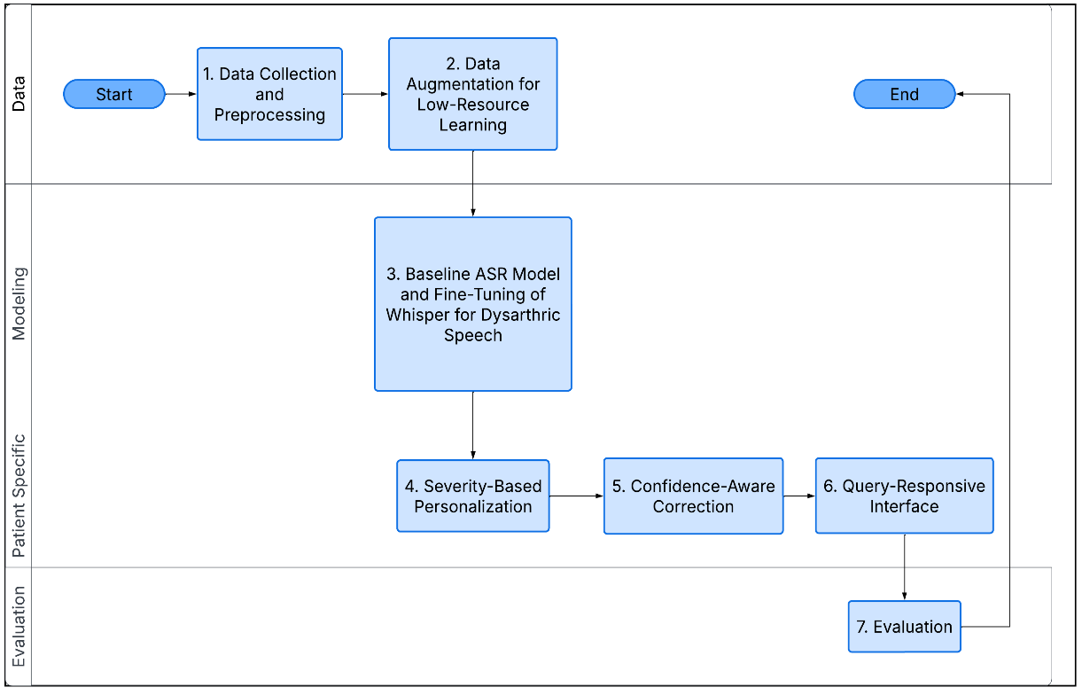
Methodology
The methodology is structured into multiple stages, covering data preparation, model adaptation, personalization, and system integration.
- Data Collection and Preprocessing
A dysarthric speech dataset in Hindi will be utilized, consisting of paired audio recordings and corresponding text transcripts. Given the variability in recording conditions and speaker characteristics, a preprocessing pipeline will be implemented to standardize the data.
Audio signals will be:
- Resampled to 16 kHz mono format.
- Normalized to maintain consistent amplitude levels.
- Segmented into shorter utterances (5–15 seconds).
- Cleaned by removing silence and background noise where necessary

- Data Augmentation for Low-Resource Learning
Due to the limited availability of dysarthric speech data, targeted data augmentation techniques will be employed to enhance dataset diversity while maintaining computational efficiency.
The augmentation strategies include:
- Speed perturbation (slight variations in speaking rate)
- Pitch shifting (to simulate vocal variability)
- Additive noise injection (to improve robustness)
These lightweight techniques increase the effective training data without requiring complex generative models, thereby aligning with the goal of data efficiency.
- Baseline ASR Model Establishment and Fine-Tuning of Whisper for Dysarthric Speech
A baseline performance will be established using a pretrained Whisper model without fine-tuning. This model will be evaluated on the dysarthric dataset to measure the initial performance using metrics such as Word Error Rate (WER). This baseline would serves as the reference for assessing improvements we have achieved through subsequent adaptations via fine tuning on the model. We will fine tune the Whisper model on the processed and augmented dataset to adapt it to dysarthric speech characteristics. Key aspects of the fine-tuning process include:
- Supervised training using audio-transcript pairs
- Use of a low learning rate to preserve pretrained knowledge
- Training for a limited number of epochs to prevent overfitting

- Severity-Based Personalization
A classification module will categorize speech into severity levels (e.g., mild, moderate, severe). The ASR system will use this information to adapt predictions, enabling user-specific or severity-aware performance.
- Confidence-Aware Correction
A confidence estimation mechanism will identify low-confidence outputs and apply correction strategies (e.g., alternative predictions or context-based refinement) to improve reliability.
- Query-Responsive Interface
The recognized text will be processed to detect user intent and generate appropriate responses, enabling interactive assistive communication.
- Evaluation
System performance will be evaluated using Word Error Rate (WER), latency, and accuracy across severity levels, comparing baseline and fine-tuned models.

Work Plan
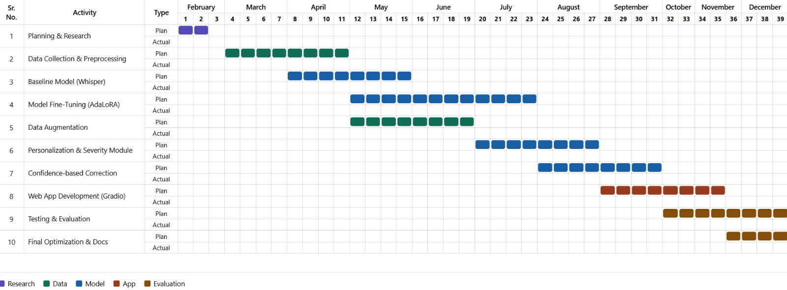

Project Outcomes & Individual Roles
● Lightweight Personalized Hindi Dysarthric ASR System:
A browser-based speech recognition system built on Whisper-small, adapted for dysarthric Hindi speech. The system is expected to significantly reduce word error rate compared to baseline Whisper models by incorporating personalization and dysarthria-specific adaptations.
● Data-Efficient Fine-Tuning Framework:
A training pipeline using parameter-efficient techniques such as AdaLoRA, curriculum learning, and synthetic augmentation. This framework aims to enable effective model adaptation using limited dysarthric speech data (1–2 hours per speaker), addressing the challenge of data scarcity.
● Severity-Aware Recognition and Error Handling:
An adaptive mechanism that accounts for different levels of dysarthria severity using confidence-based filtering (WhisperX) and language model rescoring (IndicBERT). This is expected to improve robustness, especially for low-intelligibility speech segments.
● Interactive Assistive Web Interface:
A Gradio-based interface providing real-time transcription with microphone input, confidence visualization, and correction tools such as replay and edit options. The system is designed to improve communication efficiency in everyday scenarios.
● Benchmarking on Hindi Dysarthric Speech Dataset (HDSD):
Evaluation of the proposed system on the HDSD dataset to establish baseline and improved performance metrics for Hindi dysarthric ASR, contributing to future research in this domain.
Individual Team Member Roles
- Jivitesh Pasrija (Team Lead & Core ML Development):
Responsible for overall project direction and system design; working on Whisper model adaptation, implementation of AdaLoRA fine-tuning, and integration of augmentation and personalization techniques.

- Edwin Raphael (Core ML Development & System Integration):
Working on backend pipeline for model inference and integration of faster-whisper with the web application; focusing on optimizing performance for real-time processing.
- Akhil Mittal (Data Processing & Model Training):
Handling dataset preparation (HDSD), preprocessing pipelines, and assisting in training, tuning, and evaluation of ASR models.
- Kanishka Bhardwaj (Frontend Development):
Designing and developing the user interface using Gradio; implementing user interaction features such as microphone input, transcription display, and feedback visualization.
- Arpita Tejpal (NLP & Error Correction Module):
Working on language model integration (IndicBERT) for rescoring and correction; focusing on handling low-confidence predictions and code-mixed Hindi-English inputs.

Course Subjects
Machine Learning (UML501): To understand model training and fine-tuning techniques like AdaLoRA, along with evaluation using metrics such as Word Error Rate (WER) for improving speech recognition performance.
Artificial Intelligence (UCS411): To learn intelligent system design and decision-making, which helped in implementing confidence-based processing and improving transcription accuracy.
Probability and Statistics (UMA401): To apply statistical methods for confidence scoring, uncertainty handling, and performance evaluation of dysarthric speech recognition.
Conversational AI: Speech Processing & Synthesis (UCS749): To gain knowledge of speech signal processing and ASR systems, enabling effective handling and augmentation of dysarthric speech data.
Conversational AI: Natural Language Processing (UCS664): To understand language models and text processing, used for rescoring outputs and handling Hindi-English code-mixed speech.
UI & UX Specialist (UCS542): To design an accessible and user-friendly interface with features like real-time transcription, confidence visualization, and interactive controls.

References
[1] Z. Qian and K. Xiao, “A Survey of Automatic Speech Recognition for Dysarthric Speech,” Electronics, vol. 12, no. 20, p. 4278, 2023.
[2] A. Aboeitta et al., “Bridging ASR and LLMs for Dysarthric Speech Recognition,” Proc. Interspeech, 2025.
[3] H. Kim et al., “UASpeech: A Dysarthric Speech Database,” Proc. Interspeech, 2020.
[4] F. Rudzicz et al., “The TORGO Database of Acoustic and Articulatory Speech from Speakers with Dysarthria,” Language Resources and Evaluation, vol. 46, no. 4, pp. 523–541, 2012.
[5] M. Soleymanpour et al., “Accurate Synthesis of Dysarthric Speech for ASR Data Augmentation,” arXiv, 2023.
[6] M. Tripathy, “Hindi Dysarthric Speech Database (HDSD),” IIT Roorkee, 2025.
[7] A. Radford et al., “Robust Speech Recognition via Large-Scale Weak Supervision,” 2022.
[8] A. Baevski et al., “wav2vec 2.0,” NeurIPS, 2020.
[9] T. Javed et al., “IndicVoices Dataset,” 2024.
[10] Transfer Learning for Dysarthric Speech Recognition, IEEE.
[11] Speaker Adaptation Techniques, IEEE.
[12] D. Amodei et al., “Deep Speech 2,” ICML, 2016.

